An Explanation of the Source Code of Days After Summer
By iRobit

The days after summer is a narrative-driven game developed in C using the raylib graphics library. The game explores a story inspired by the five stages of grief, where each stage is represented by a different floor in an elevator. Each floor contains a short gameplay segment that reflects the emotional theme of that stage.

The game aims to demonstrate the experiences of someone going through a hard time in their life, and ends with coming to terms and moving on from their traumatic experience.

The game is built and edited using Visual Studio Code, with compilation done through the GCC compiler included in w64devkit.

Compilation Instructions
To compile and run the project, the following tools are required:
- raylib – graphics/game development library
- GCC – C compiler
- w64devkit – MinGW-based development environment used with raylib
- Visual Studio Code – code editor used during development

Build Instructions (Windows only)
- Open a terminal in the project root directory.
- Compile the project using the raylib toolchain:C:\raylib\w64devkit\bin\gcc.exe src/*.c -Iinclude -IC:/raylib/w64devkit/x86_64-w64-mingw32/include -LC:/raylib/w64devkit/x86_64-w64-mingw32/lib -lraylib -lopengl32 -lgdi32 -lwinmm -o game.exe
- Run the game

Why we used the tools we did:
- Raylib - a beginner friendly game development tool. We used it to add graphics rendering, input handling, sound playback and window management. Raylib allowed all this in a neat package, which is why we chose it over C libraries.

- Visual Studio Code - this is a must for most C++ developers, especially amateurs to the programming space like us, as this allows us to write, compile, and debug code from one place. In addition, it provided syntax highlighting, debugging support and integrated terminal, which was a big help with debugging.

- GCC / w64devkit - Compilation is handled by GCC, distributed through w64devkit. This toolchain is recommended for raylib because it ensures compatibility between the compiler and raylib libraries.

- AI tools - we used chatgpt and github copilot to help with code generation. That of course, did not mean our work was not cut out for us, since these tools often made mistakes or did not generate the code exactly as we wanted it to, most of the time we would alter the code to suit the environment perfectly before adding it to our workspace.

Our Development Approach
Because of the nature of our game, we structured it into modular components, with each major section of gameplay separated into its own source file.
Some examples include:
elevator.c – elevator transitions between stages
evel1.c – gameplay for the first stage
level2.c – gameplay for the second stage
ending.c – ending sequence
This modular structure allows multiple team members to work on different systems simultaneously without interfering with each other’s code.
We will go further into detail about the thinking behind our development at the “folder structure explanation” section.

Our Folder Structure
The project is organized into multiple directories to separate different parts of the game, making the code easier to understand and maintain. Our workspace is split into 3 separate folders: source code, include and assets folder:

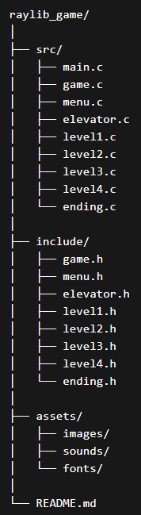
- The src folder contains all C source files (.c) that implement the game’s functionality. Each file corresponds to a specific system or gameplay stage.
Examples:
- main.c
The entry point of the program. It initializes the game window, sets up the main game loop, and calls the main game logic functions.
- game.c
Handles the core game logic, such as managing the current state of the game (menu, gameplay, ending).
- menu.c
Implements the main menu where players can start the game or exit.
- elevator.c
Controls the elevator mechanic used to move between different floors, which represent the different stages of the story.
- level1.c – level4.c
Each file implements the gameplay logic for a specific level or stage.
- ending.c
Handles the ending sequence once the player has completed all stages.
- Zuma.c, which handles the logic and the execution of the zuma game that happens in level 3.c
- The include folder contains all header files (.h), which define the functions, structures, and variables used across multiple source files.
Header files serve two main purposes:
- Function declarations – allowing different source files to call functions from other modules.
- Code organization – separating interface definitions from implementation.
For example:
- game.h declares functions related to overall game logic.
- menu.h declares menu-related functions.
- level1.h declares functions specific to level 1 gameplay.

Assets Folder (assets)
The assets folder stores external resources used by the game, such as:
- Images (sprites, backgrounds, UI elements)
- Sound effects
- Music
- Fonts

Design Reasoning for This Structure
The project uses a modular structure where different parts of the game are separated into their own files and directories. This approach was chosen for several reasons:
- Improved readability – smaller files are easier to understand.
- Team collaboration – different developers can work on separate modules simultaneously.
- Easier debugging – problems can be isolated to specific components.
- Scalability – new levels or systems can be added without modifying existing files extensively.
Overview of the Program Structure

Your game is structured using a state-based system.
This means the program is always in one of several states, such as:
- Menu
- Elevator
- Level 1
- Level 2
- Level 3
- Level 4
- Ending
Each state has its own update function that runs every frame.

Program Execution Flow

1. Program Start
int main()
The program begins here.

2. Get Monitor Resolution
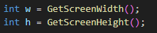
This gets the resolution of the monitor.

3. Create the Window
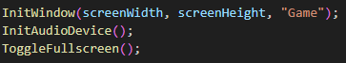
Creates the window where the game is drawn, allows sounds and music to work, and
The window switches to fullscreen mode.

6. Hide Mouse Cursor
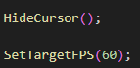
Since the game is keyboard controlled, the cursor is hidden, and the game sets to run at 60 frames per second.

7. Load Assets
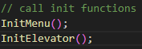
These functions load:
- textures
- sounds
- backgrounds

8. Set Initial State
GameState state = MENU;
The game starts in the menu.

The Main Game Loop
This is the heart of the program.
The loop runs every frame until the user closes the game.
Each frame does:
- Begin drawing
- Update current game state
- Draw graphics
- End drawing

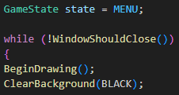

State Switch System
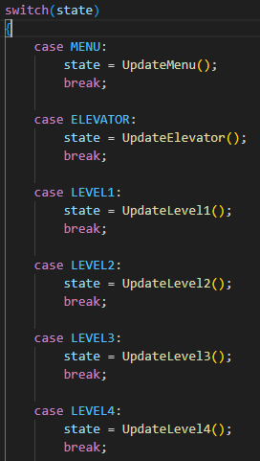
This checks which state the game is currently in.

MENU
The menu logic runs.
If the player presses start, the function returns:
ELEVATOR
Which changes the state.

ELEVATOR
state = UpdateElevator();
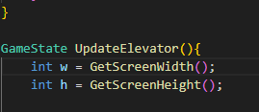
Handles:
- dialogue
- animations
- level selection

LEVELS
state = UpdateLevel1();
state = UpdateLevel2();
...
Each level contains its own gameplay.

ENDINGS
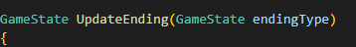
Different endings depend on choices made earlier.

End Drawing
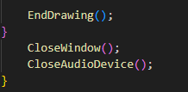
The frame is finished and shown on screen.
When the loop ends:
CloseWindow();
CloseAudioDevice();
The program safely closes.

2. elevator.c — Elevator Hub System
The elevator is the central hub between levels.
It handles:
- intro animations
- dialogue
- level selection

Initialization
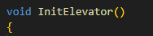
Runs once when the elevator loads.
It loads textures:
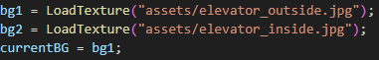
These are the background images.

Reset Animation Variables
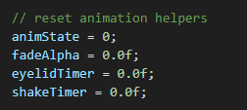
These control the intro animation sequence.

Create Placeholder Avatar
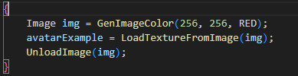
Creates a temporary red portrait image.
This is used in dialogue boxes.

This function runs every frame while the player is in the elevator.

Step 1 — Screen Size
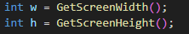
Used to position UI elements.

Step 2 — Animation Sequence
Before the player can choose levels, an animation plays.
There are 3 animation phases:

Phase 0 — Fade In
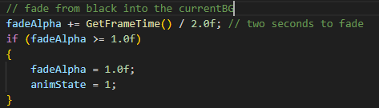
The screen fades from black to the background.
When finished:
animState = 1

Phase 1 — Eyelid Animation
Two rectangles close like eyelids:
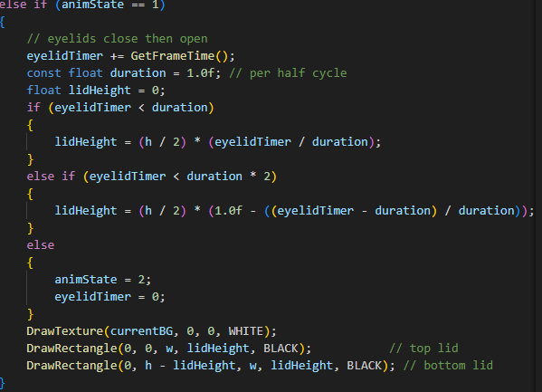
This simulates blinking. It works because the two if statements keep going until the duration timer is up, which is 2 seconds total.

Phase 2 — Elevator Shake
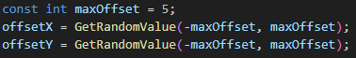
The background shakes slightly to simulate elevator movement.
After 2 seconds:
animState = 3
Animations end.

Step 3 — Dialogue System
Dialogue initializes using:
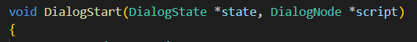

Dialogue Case 0
Shows the first dialogue:
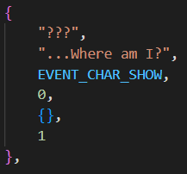
The dialogue function returns 0 when finished, advancing the state.
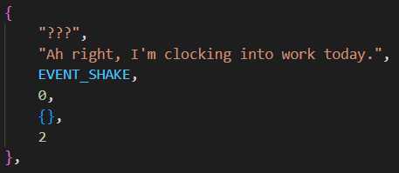
Once the player gets an option, this line plays:
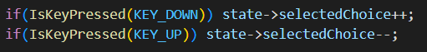
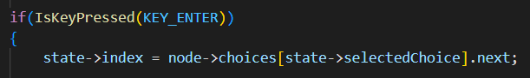

Step 4 — Level Selection
After dialogue finishes:

Player can choose a level.

Navigation
UP / DOWN arrows
change:
selected_el

Drawing Level Buttons
Example:
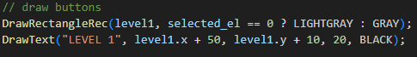
Unlocked levels are shown.
Locked levels are hidden.
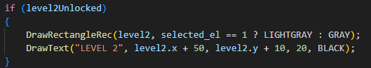

Selecting Level
ENTER
Returns the chosen state:
return LEVEL1
The main loop then switches state.

3. level1.c — First Level
This is currently a placeholder level.

Function
Runs every frame while in level 1.

Draw Text
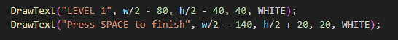
Displays instructions.

Finish Level
If player presses space:
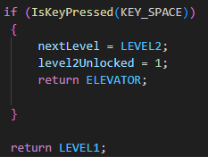
Then:
level2Unlocked = 1
This unlocks the next level.
And returns:
return ELEVATOR
Which sends the player back.

4. menu.c — Dialogue System

Dialogue Features
The system includes:

Animated Text
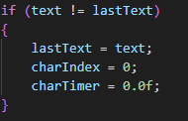
Characters appear gradually.
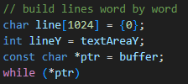
Every frame reveals one character.

Skip Text
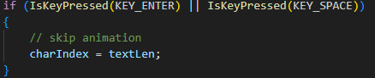
Press:
ENTER or SPACE
to show the full text instantly.

Word Wrapping
Because the raylib version lacks DrawTextRec, the code manually wraps text.
It builds lines word by word and checks width using:
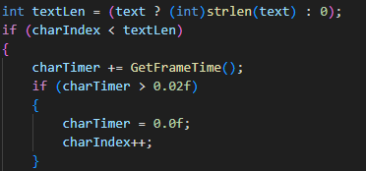

Dialogue Options
Players can select responses.
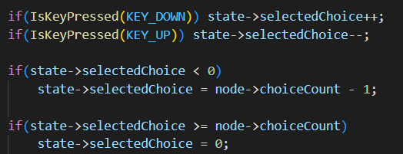
Navigation:
UP / DOWN
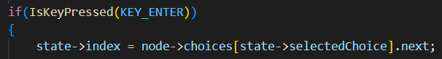
Selection:
ENTER
The function returns:
0, 1,2
depending on which option was chosen.

Global Game Variables (game.c)
These variables control overall game progress.

Next Level

Stores the next level to load.

Score Counters
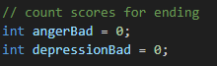
These track choices affecting the ending.

Level Unlock System
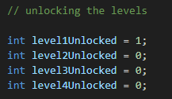
Controls which levels appear in the elevator.

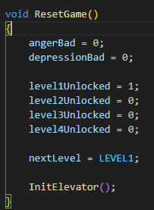
Resets the entire game state.
Used when restarting.
It:
- resets scores
- locks levels again
- returns to Level1
LEVEL 3 Fighting Mini-game
This level now includes a turn-based RPG fighting system.
The level has 3 phases:
- Dialogue phase
- Battle phase
- Result phase
This is controlled using:
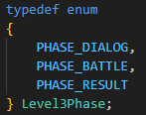

Fighting System (Level 3)
The player fights an “evil version” of themselves.
The system tracks:
- Player HP
- Enemy HP
- Healing count
- Guard state
Example:
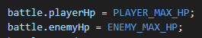

Player Actions
The player can press:
- A → Attack
- G → Guard
- H → Heal
This is handled in:
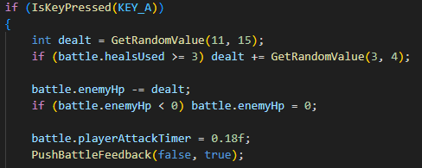

Smooth HP Animation
Instead of HP instantly changing, it smoothly updates:
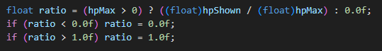
This makes the game feel more polished and less “instant”.

Battle Feedback
The game adds:
- Screen shake
- Hit flash
- Attack animations
Example:
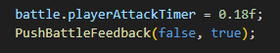

Zuma Minigame in Level 4:
The minigame is handled using:
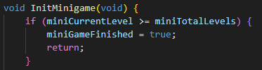
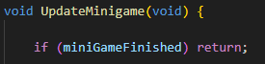

How It Works
- The player shoots projectiles
- Matches colors
- Clears chains
The game checks if the player has won:
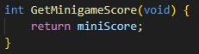

Transition from Dialogue → Minigame
After dialogue ends:
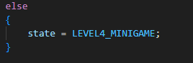

This connects story and gameplay together.
ENDINGS (Updated Section)
The ending system is now based on player choices.
The game tracks negative actions using:
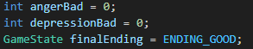

Ending Calculation
At the end of the game:
int total = angerBad + depressionBad;

Ending Types
Depending on the value:
- High value → Bad Ending
- Medium → Slightly Bad Ending
- Low → Good Ending
Example:
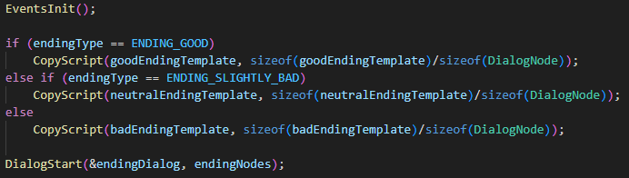

Overall Execution Flow
When the game runs:
Start Program
↓
Initialize Window
↓
Load Assets
↓
Enter Game Loop
↓
MENU
↓
ELEVATOR (dialogue + animations)
↓
LEVEL1
↓
ELEVATOR
↓
LEVEL2
↓
LEVEL3 (with fighting minigame)
↓
LEVEL4 (with zuma game)
↓
ENDING

Conclusion
We are overall quite satisfied with our development progress in the programming front. We have a very solid ground work and structure, so adding new functions and assets should be much easier because of this.
We will continue to develop our project by working on the limitations we mentioned previously, and are excited to see the development of the game through to the end.

AI Usage
The two main AI tools used in this project were ChatGPT and Copilot, and they were used for:
- Generating reference code, especially when we didn’t know how to exactly implement a certain system. We made sure to not just copy paste the code but to actually understand what each line actually did and why it was needed.
- Debugging, like when the bug was not obvious from some testing, or the bug was caused from a very deep structural error.
- Explaining and commenting on the structure and the inner workings of the code. This made us better programmers and allowed us to continue working without AI for some parts.

